1. Human Resource Activity
   1. Create three classes: **Employee**, **Department**, and **Company** Class.

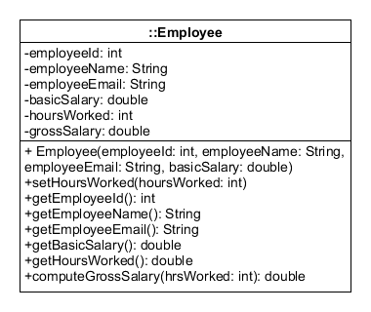

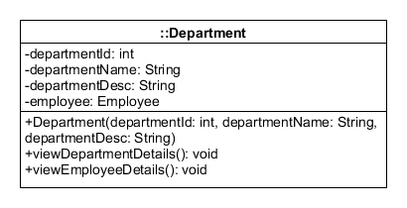

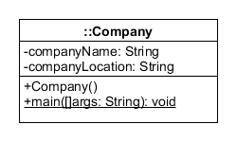

* 1. Using the UML diagram, Company class has the main method. Instantiate one object for each classes. Set all the values from their respective declared constructors.
  2. The program starts by printing the company name and location. Ask for the hours worked by the employee using the mutator method. Print out the department details and the employee details afterwards.
  3. The computeGrossSalary() method under Employee class computes the gross salary of the employee using one parameter of int as the hours rendered multiplied by the basic salary of the employee then returns the result.
  4. The viewDepartmentDetails() method prints all the information about the department: Department ID, Department Name, Department Description.
  5. The viewEmployeeDetails() method, under the Department class, prints all the information about the employee: Employee ID, Employee Name, Employee E-mail, Employee’s Basic Salary, Employee’s Gross Salary.